Queen’s College, Taunton Lodge Christmas Meeting and Lunch 9th December 2023
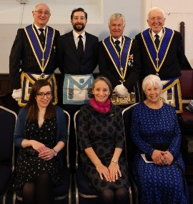
There was a flurry of activity at TMC at 8.30am on 9th when WBro Geoff Dolling arrived to begin organizing the lodge room for our meeting, shortly joined by WBro Andy Humphries. Our caterers had copious amounts of tea, coffee and biscuits available from 10.15. A short business meeting began at 11.am during which WBro Jonathan Dolling was unanimously confirmed as Master Elect for installation on Saturday 11th March. This meeting marked the first visit to 6988 of Bro Miles Frewin, initiated in to Globe Lodge No. 23 last March, son of WBro Lionel. Miles is pictured with his godfathers on either side. On conclusion of this formal meeting, alms were collected and the National Anthem was sung. From Alms of £292, £62 is added by use of Gift Aid envelopes!
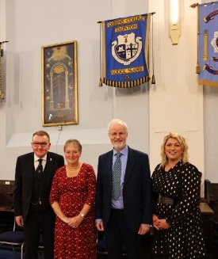
Unfortunately, a demonstration of cake decorating arranged for our Ladies and guests was abandoned as the person was poorly but a cake had been baked and decorated which was added to items for auction. Later, WBro Lionel’s auction bid for it was successful. He presented the cake to Emma Busby*.
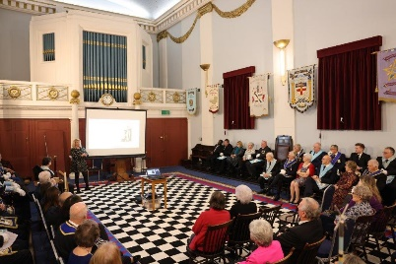
Our Ladies and other guests were invited to join us for a talk about ‘Open Door’ for the Homeless of Taunton, our Wm’s chosen charity for his year. This talk was given by our guests, Emma Busby*, Manager, supported by a Trustee, Andrew Davies photographed with our Wm Lindsay and his wife Melanie. The interesting talk prompted many questions which came fast and furious. For more information: https://www.tauntonopendoor.org.uk/

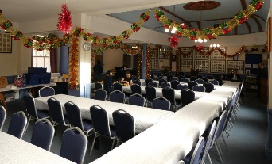
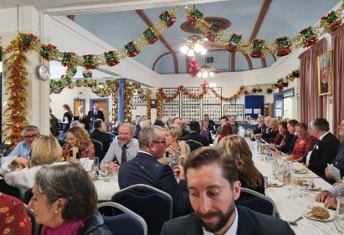
At the conclusion of the talk we adjourned for a ‘sparkling’ reception generously provided by our Wm Dr Lindsay Edmunds when Julian Noad, Headmster, visited briefly. Geoff Bisson celebrated 50 years at Queen’s as Guest of Honour at Speech Day. He and Sarah were our guests, too. The dining room had been spectacularly decorated by the caterers, Hayley and Karen, tables laid for 80+ diners, which stand out in the following pictures taken, predominantly by WBro Jim Wiltshire, many of which appear overleaf. As usual, we enjoyed an excellent traditional Christmas meal with copious amounts of clotted cream accompanying dessert, mince pies with port.
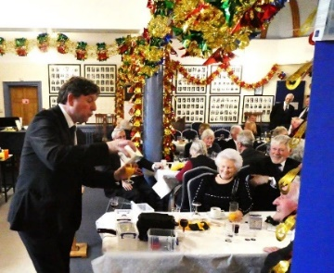
During coffee WBro Jonathan Dolling stepped forward briefly to remind us of his conjuring skill with what seemed to be a carton of a well- known brand of orange juice. Having poured a glass of juice, he proceeded to pour red, white and sparkling wines in to different glasses - all from the same carton! Talking of wine, our Wm rose to propose a toast to our Ladies at the same time taking the opportunity to thank a variety of brethren for their help with the day’s arrangements, particularly WBro Graham Tenbroeke who organised the table plan and those who had dispensed the essential refreshments!
As you will see overleaf, our Wm’s wife was keen to respond to the Ladies’ Toast!

As ever, when it came to the raffle, brethren had been generous in providing a large selection of prizes, the most significant of which were set aside for auction. Our Charity Steward, WBro Jim Wiltshire had been busy devising a new system which replaced the selling of tickets with numbered counters of different colours. The advantage being avoiding the tedious tearing up of tickets which never separated sufficiently when being drawn out! If there were any teething problems it certainly didn’t affect the generosity of everyone, as the final totals bear out.

Generosity is a word rightly used frequently, evidenced with WBro Alan Watkins inviting so many guests and also providing a giant bottle of Jamesons Whiskey which attracted fierce bidding at auction, conducted by WBro Geoff Dolling is his inimitable and compelling style. What entertainment he provides! Thanks, Geoff!
THE AMAZING SUM OF £1580 WAS RAISED TODAY WITH PROVINCE ADDING A FURTHER £500! Thank you ALL!
